Introduction to Cloud Solutions Lab Report
Use this template to document your work as you complete the associated lab instructions.

Your Information
Your Name:
Lab Title: Storing and Accessing Templates with Git and GitHub

Instructions
Follow the instructions to answer the questions related to the lab and add the required screenshots. Submit your completed report following the instructions in Canvas.

Section Uploading to GitHub
1. Step 5 Screenshot: GitHub account and commit information
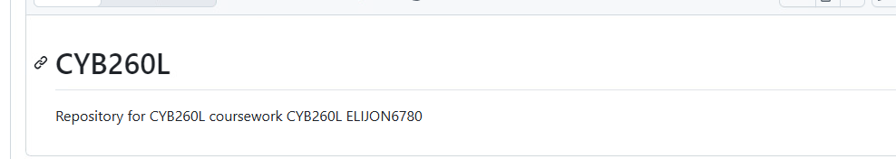

Section Downloading, Installing and Configuring Git
2. Step 18 screenshot: Contents of the local Git repository

